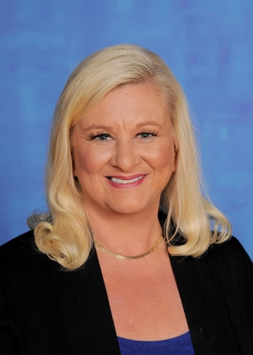

Superintendent Dr. Andie Webb is a graduate of Washington State University in Agriculture Education and Economics. She taught for 11 years and served as a coach and FFA advisor. Through dedication to a strong, vital K-12 system, it is Dr. Webb's greatest hope and ambition to see that all students receive the experiences that will allow them to thrive, and an education that will take them anywhere they want to go.

Dr. Webb earned her masters in administration and her doctorate in Education Leadership from WSU. She has 6 brothers and 14 nieces & nephews. This year marks the beginning of year 31 in education. She has served her state association in CTE, the WIAA as an official for 16 years and is a proud COUG.

Email me at Andie.Webb@kahlotussd.org

